King Cobra
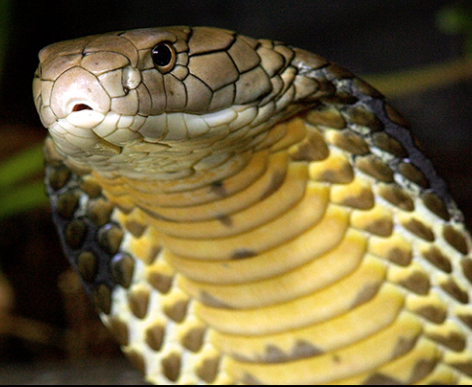
123 Elm Street | Gmail@gmail.com | 865-599-1234

Avid badass for 10+ years specializing in kicking ass, climbing, kayaking,
mountaineering, downhill mountain biking, free diving, winter camping,
and HALO jumps.

Search and Rescue Related Experience
- GSMNP SAR AD Hire (2013-present)
Certifications and Classes
- Work Capacity Test – Arduous Level – 2020
- National Park Service Basic SAR Training
- NASAR SARTECH III
- Backcountry Safety and Survival Course – Big Pig Outdoors
- Wilderness First Responder (WFR) – Landmark Learning/NOLS
- Basic Aviation Safety, A-100
- ICS 100 – Introduction to Incident Command System
- ICS 200 – Single Resources and Initial Action Incidents
- ICS 700 – National Incident Management System
- ICS 800 – National Response Framework, an Introduction.
- Orienteering/Advanced orienteering

Fitness
Whipping ass for 10 years + in everything imaginable
- Kicked Chuck Norris’s ass.
- BASE jumped into the Colorado River in my kayak.
Other
- Invented a sky diving wing suite for cats.

